Miles Shinsato

11/17/2024

Module 5.3 Assignment

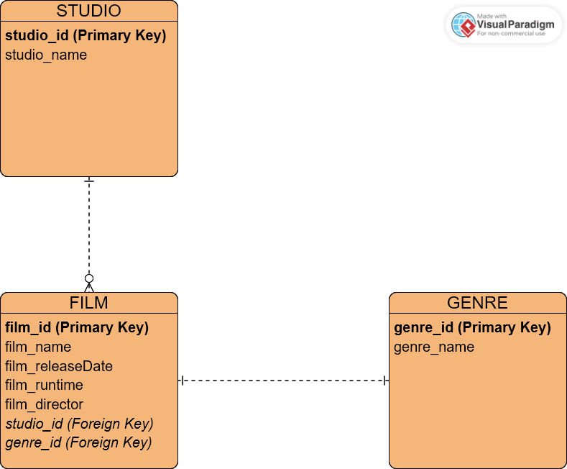CSD310-A339